Chapter 5 Magnetic field and force
Chapter Test Answers Total marks 46

Question 1
- Two wire conductors run parallel to each as shown below. Draw the direction of conventional current through the wires to create a force of attraction between them.
(1 mark)

Description | Marks
Direction of current same in both wires | 1



- Draw lines around the solenoid below to represent both the direction and strength of the magnetic field that is created around it when a current flows through it.
(3 marks)

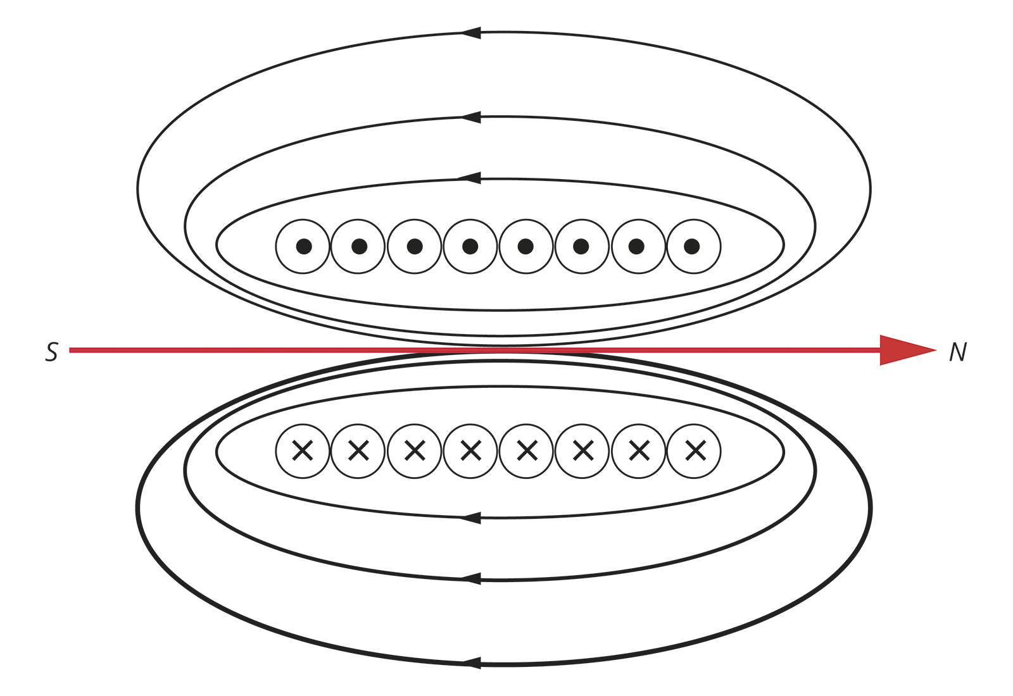

Description | Marks
Direction of current shown | 1
Direction of magnetic field shown (for given current direction) | 1
Field strength represented by greater separation between lines as they move away from wires | 1

- To determine the charge on radiation emitted from the decay of a new radioactive nucleotide, the radiation is directed through a magnetic field as represented in the diagram below. When the radiation passes through the field it is deflected upwards. What is the charge on the radiation? (1 mark)

Description | Marks
Direction of current same in both wires | 1

Question 2
A mass spectrometer measures the mass of a charged particle by allowing the particle to enter a uniform magnetic field at a known velocity. The charged particle will experience a force when it enters the magnetic field and travels in a circular path. Its mass is determined by the radius of the path it follows. The diagram below represents the behaviour of a charged particle when it enters the uniform magnetic field of a mass spectrometer.

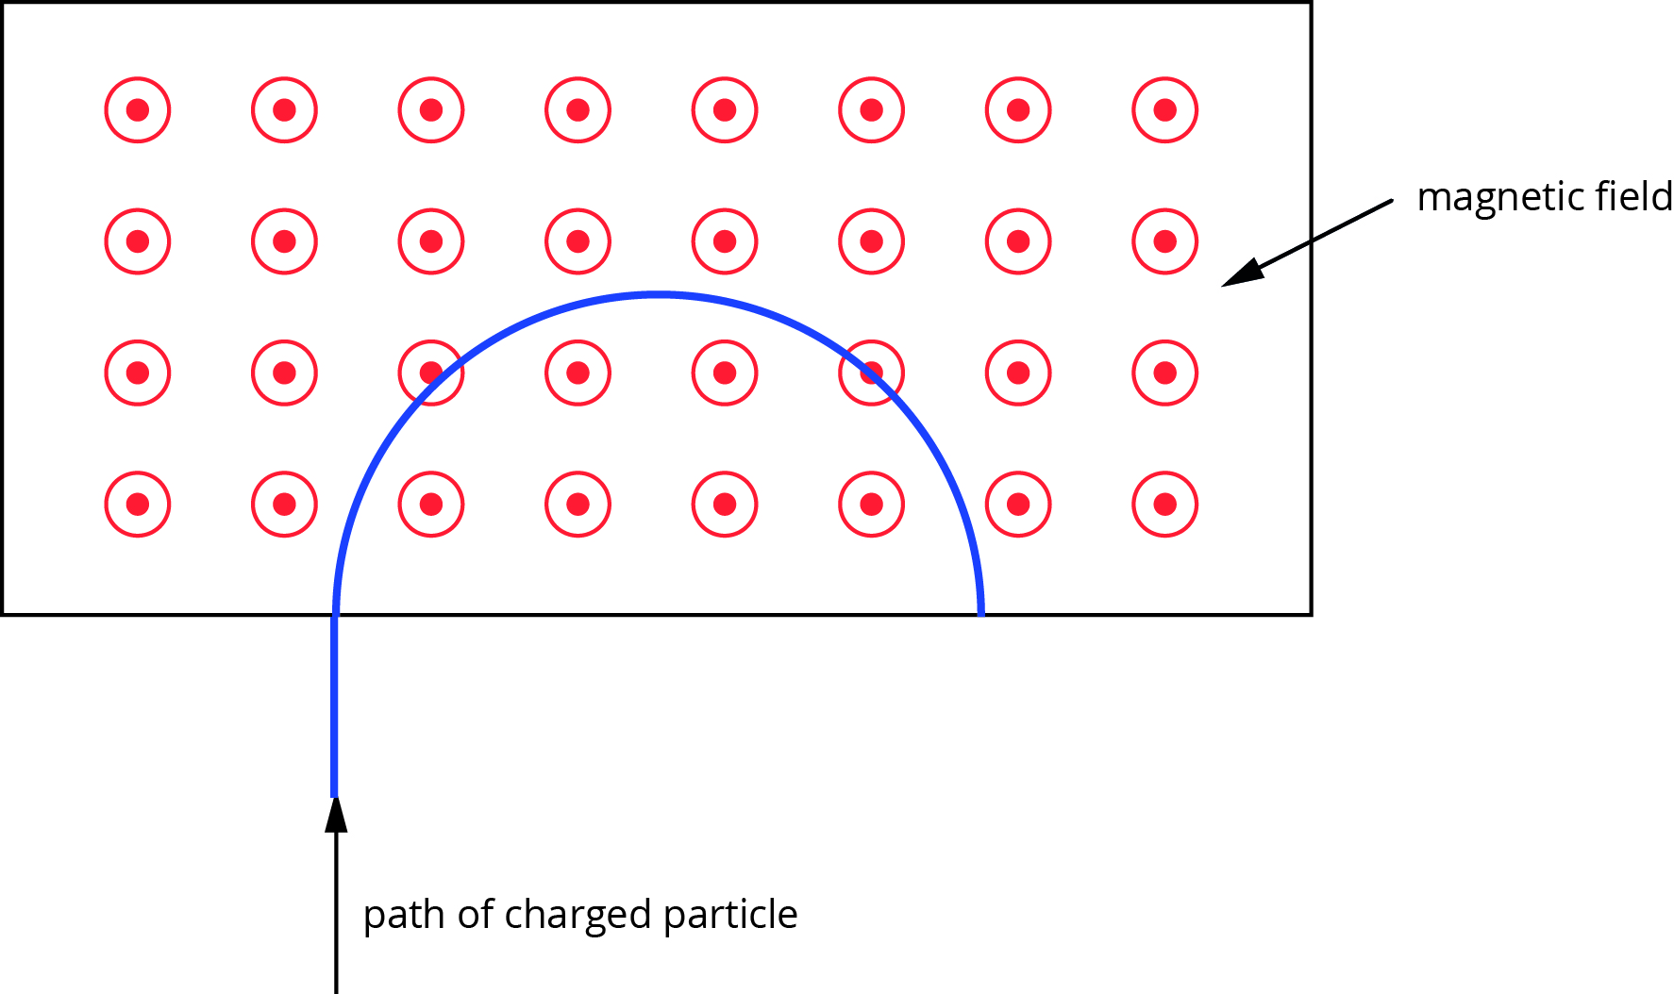

- What is the magnitude of the force experienced by a particle with a charge of one positive and velocity of 2.74 × 10⁵ m s⁻¹ when it enters a mass spectrometer with a magnetic field of 0.525 T? (3 marks)

Description | Marks
F = qvB | 1
F = 1 × 1.60 × 10⁻¹⁹ × 2.74 × 10⁵ × 0.525 | 1
F = 2.30 × 10⁻¹⁴ N | 1

- What is the mass of the charged particle if its circular path in the magnetic field has a radius of 19.1 cm? (3 marks)

Description | Marks
Thus, | 1
 | 2

Question 3
A proton moving in a northerly direction with a speed of 6.84 × 10⁶ m s⁻¹ in a magnetic field experiences a force of 1.255 × 10⁻¹² N towards the west. Find the magnitude and direction of the magnetic field influencing the proton. Give your answer to the appropriate number of significant figures. (5 marks)

Description | Marks
F = qvB  Thus, | 1
 | 2
Field direction is into ground | 1
Answer to 3 significant figures | 1

Question 4
A student designs a simple solenoid valve system to control flow of a liquid through flexible tubing by closing and opening the tubing. It is comprised of an iron rod with a spring coiled around it at one end. One end of the spring is attached at one end of the rod and its other end is attached to a rectangular housing. The tubing is fixed to a solid support. The system is represented by the diagram below.

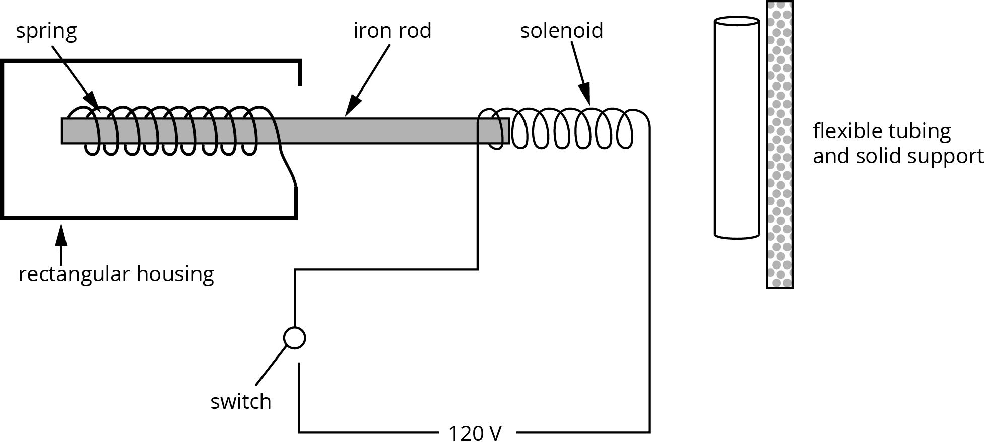

- Using the appropriate physics concepts, explain how the system will operate to close and open the tubing. (3 marks)

Description | Marks
When the switch is closed, current flows through the solenoid coils and creates a magnetic field around it. | 1
The iron rod is attracted to the magnetic field around the solenoid and moves through it, pushing the tubing against the solid support. | 1
When the switch is opened, the magnetic field goes and the spring pulls the rod back to its original position to open the tube. | 1

- Give two ways to increase the force with which the iron rod will push the tubing closed. (2 marks)

Description | Marks
Increase number of turns in coil of solenoid | 1
Increase the current (reduce resistance of wires) | 1

Question 5
A student examining a small electric motor notes that the specifications under optimal operating conditions are as follows.
torque = 2.4 × 10⁻² N m
voltage = 9.0 V
current = 1200 mA
windings = 5000 turns
To estimate the strength of the magnetic field the motor would operate with under optimal conditions, the student measures the cylindrical motor and estimates the length of the armature coil of the motor to be 3.0 cm with a diameter of 1.8 cm.

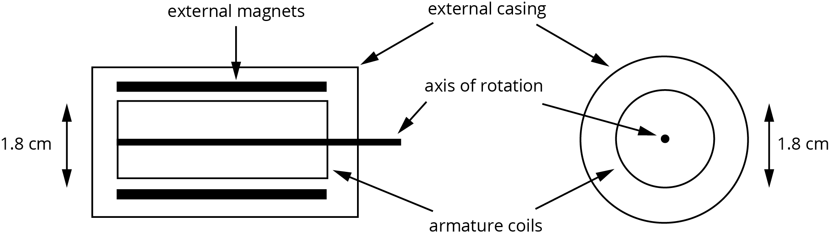

- When operating under optimal conditions, what force would the moment arm of the motor experience? (3 marks)

Description | Marks
τ = rF  Thus, | 1
 | 1
Each side of arm experiences half the force thus,  F = 1.3 N | 1

- Estimate the magnetic field strength for the motor by carrying out the appropriate calculation. (3 marks)

Description | Marks
F = IℓB  Thus, | 1
 | 2

- As the armature on an electric motor such as this spins, there needs to be a change in direction of the current through the coil every half turn. Explain why this is necessary for the motor to operate successfully and name the part of a motor used to achieve this change in direction. (3 marks)

Description | Marks
Change of current direction is needed to keep the relationship between the direction of the magnetic field and direction of current through the armature the same. | 1
This keeps the direction of force on each side of the armature the same. | 1
Change in current direction is achieved using a commutator. | 1

Question 6
- An electromagnet at a scrap yard is used to lift a 950 kg car. The electromagnet has 200 m of wire coiled around its iron core and generates a magnetic field of 1.2 T at its surface. What current needs to pass through the coils of wire to give the required strength field? (4 marks)

Description | Marks
F = mg = 950 × 9.8 = 9 310 N | 1
F = mg = BIℓ  Thus, | 1
 | 2

- What mass could the electromagnet lift at a distance of 1.00 m from the electromagnet if it had a current of 50 A flowing through it? (5 marks)

Description | Marks
Strength of magnetic field at 1.00 m:  Thus, | 1  1
F = BIℓ = 1.00 × 10^{–5} × 50 × 200 = 0.100 N | 2
F = mg | 1

Question 7
A student wants to find the strength of a uniform magnetic field. She sets up an experiment as shown in the diagram below. A 15.0 cm long metal rod of mass 5.0 g slides along the parallel branches of the circuit (ignore friction). The rod is attached to a spring balance to measure force. The spring balance is secured so that only the spring moves. The circuit is placed in the magnetic field so that the rod is 90° to the field. When a current is passed through the circuit, the rod moves away from the fixed part of the spring balance and the force is measured on the balance.

- For the experiment to measure the magnetic field, the rod must slide towards the magnetic field. On the circuit, show the direction of conventional current flow needed to move the rod in the required direction. (1 mark)

Description | Marks
Conventional current must flow from top to bottom | 1

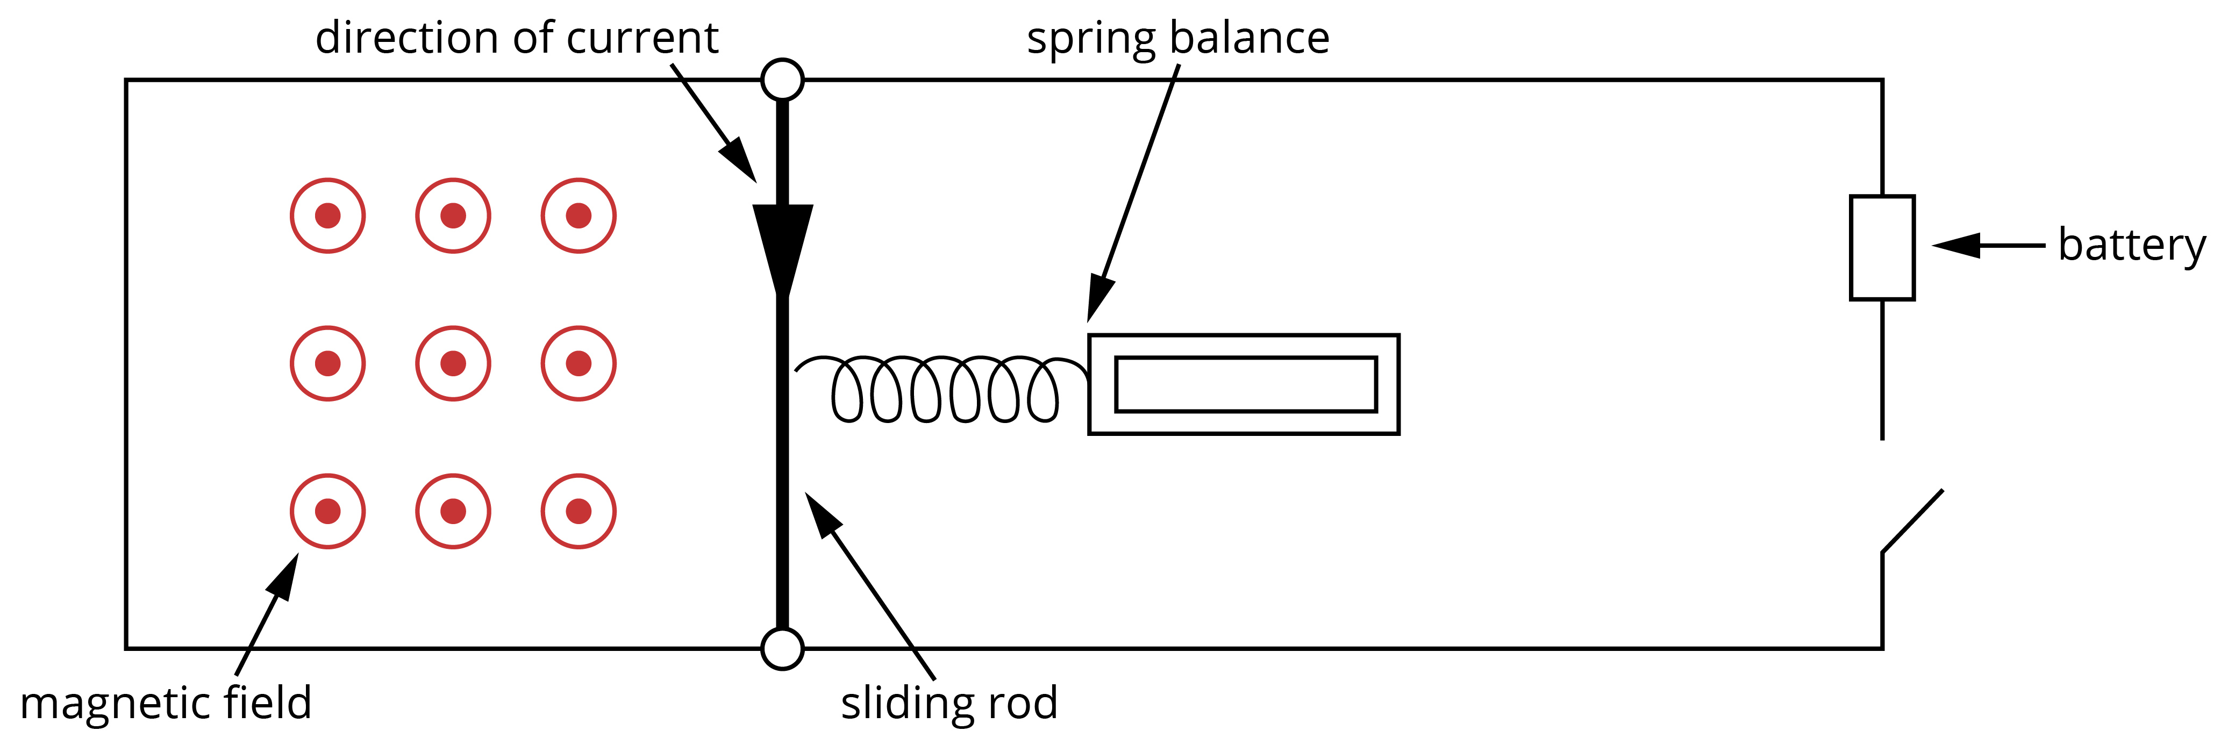

- When the 25.0 A current flows, the spring balance measures a force of 1.28 N. What is the strength of the magnetic field? (3 marks)

Description | Marks
F = BIℓ  Thus, | 1
 | 2

- When conducting another test for a different magnetic field, the circuit is bumped so that the rod is at an angle of 82° to the magnetic field. The force measured when a 15 A current is flowing is 1.06 N. What is the strength of the magnetic field? (3 marks)

Description | Marks
Force perpendicular to field:  F_{p} = F_{measured} × sin 82° = 1.06 × sin 82° = 1.05 N | 2
 | 1

